**How To Execute The Framework**

Prerequisites:

1. Apache Maven 3.9.2
2. Java Version 20.0.1

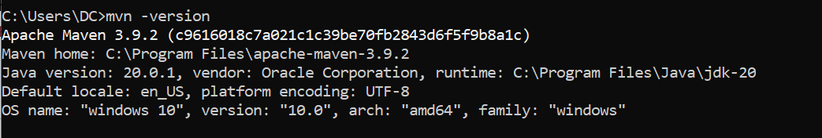

IntelliJ IDE Plugins:

1. Cucumber for Java
2. Gherkin

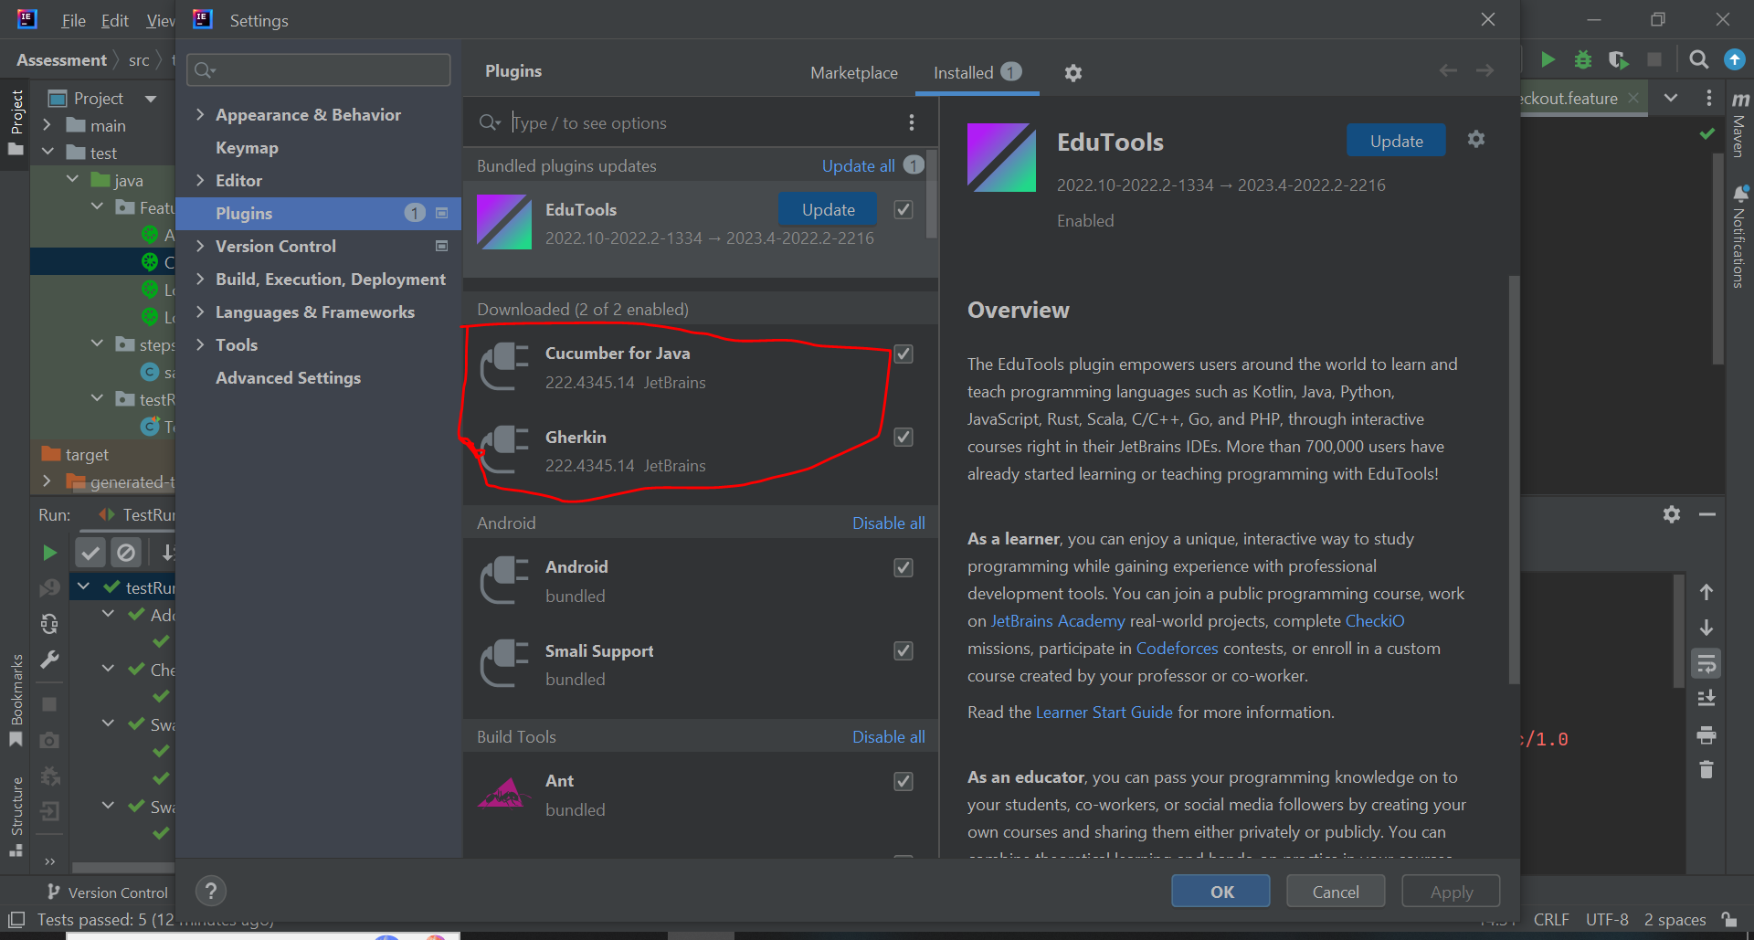

**Steps for navigating the plugins in IDE**

1. Open intelliJ IDE.
2. Click on file from the top options of IDE.
3. Then click on settings
4. Then on the left side you will see different options from their select plugins.
5. On the top of the plugin you will be having a search bar search for plugins there.

Steps for executing the framework:

1. First git clone the project repo into your local machine.
2. Open the project into your IDE.
3. Goto TestRunner class in the project.
4. From their click on play button public class TestRunner.

